PROJECT COMPLETION REPORT
Lead Encapsulation
Cinangka, Indonesia
May 2014

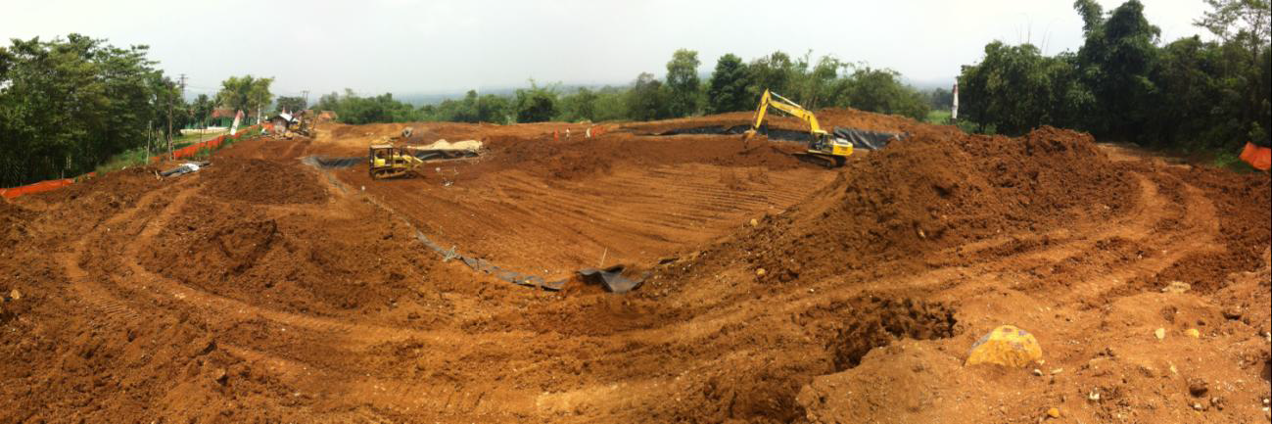

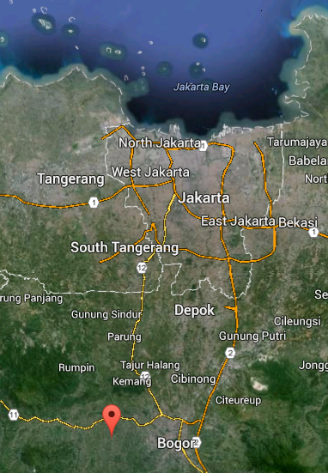
Project Details

Location | Cinangka Village, Bogor, West Java, Indonesia
Contaminant | Lead – Highly concentrated in soil
Project Duration | September 2011 –March 2014
Implementing Partners | KPBB, Ministry of Environment – Indonesia, BPPT, Regency of Bogor, Ministry of Health
Financing Partners | CLSA, SAICM, Global Alliance on Health and Pollution (GAHP)

Performance Metrics

Toxin | Lead
Affected Population | 12,500
Exposure Standards | 400 ppm soil lead levels (EPA)
Levels Prior to Project | Greater than 200,000 ppm
Levels Following Completion | <400 ppm
Cost of Encapsulation | $115,000
DALYs Averted | 3750

Executive Summary

This report summarizes the 2014 completion of a lead waste cleanup in Cinangka Village, West Java, Indonesia. Remediation methods include encapsulation and land burial to isolate legacy lead pollution from small-scale lead acid battery recycling and smelting activities. The planning and design of this project began in September 2011. Remediation activities were conducted between September 2013 and March 2014. This project is intended to both isolate a significant known source of lead poisoning in Cinangka, and serve as a pilot project to demonstrate the encapsulation method to the Government of Indonesia. The work was completed at a low unit cost/cubic meter, using local contractors and materials, with worker health protection measures. The double lined burial design was based on US land disposal methods, meeting Indonesia permitting requirements, and provides significant isolation from future environmental exposure to this lead waste. Several similar lead waste/ULAB sites have been identified in nearby settings, with associated human health impacts. The procedural and technical lessons from this project should be applied to accelerate and to multiply the cleanup of surficial lead waste sites in this area.

Background and Scope

Site Description
Cinangka Village is a high-density residential area with a legacy of lead contamination from used lead acid battery (ULAB) recycling and lead smelting. Cinangka (population ≈12,500) lies approximately 45 km SSW from metro Jakarta. The village has two main weather patterns: a rainy season, from September-March, and a dry season from April-August. Hills and dense tropical vegetation characterize the region, including the Gunung Salak volcano on the lower out-slopes. Areas without dense vegetation are likely among the many small and mid-scale farms on terrace or flat zones. Community living also maintains the naturalism of the area’s landscape. Homes are typically found in tightly packed clusters of single story stone and concrete. Front and back yards with substantial vegetation line most homes. Children often play in convoluted alleys and community areas. The winding roads are comprised of asphalt with sidewalks and alleys made mostly of packed soil and occasional concrete.

Contamination Description
Cinangka is home to numerous small-scale used lead acid battery (ULAB) recycling facilities that both melt and smelt expended lead acid batteries. These operations occur within the village proper but are hidden from street view with concrete walls and fencing, and are a primary income source for some village residents. In addition to these active operations, there are legacy-waste dumpsites in central community areas throughout the village.

Used Lead Acid Battery (ULAB) recycling is often conducted in informal work settings with minimal worker protection, and is identified as a potent source of lead contamination and damage to human health. Previous investigations by Blacksmith Institute and KPPB, an Indonesian non- governmental organization, have identified elevated blood lead levels in the local population. Field-testing found high levels of lead in near surface dump sites from broken battery casings, battery insulation, and mixed lead smelter waste.

Prior to involvement from Blacksmith Institute or KPPB, lead waste from former smelting activities in the Cinangka area was collected and disposed in shallow burials and surface dumps around the village soccer field and the adjacent ravine. In some areas, bamboo was planted over the surface heaps as a remediation method, and in other areas a layer of clean dirt fill was used as cover. Outcrops of battery casing fragments and internal battery insulation materials were exposed due to eroding dumpsites. A calibrated XRF field meter was used in fieldwork conducted in 2011-2013 to map the extent of surface lead concentrations greater than 400 ppm, the USEPA limit for lead in residential soil. In the course of this work, many near-surface locations with lead concentration greater than 200,000 ppm were identified. This work resulted in a map of known contamination greater than 400 ppm, and an estimated volume of contaminated soil of over 2500 cubic meters (See Figure 1, Extent of Soil Contamination).

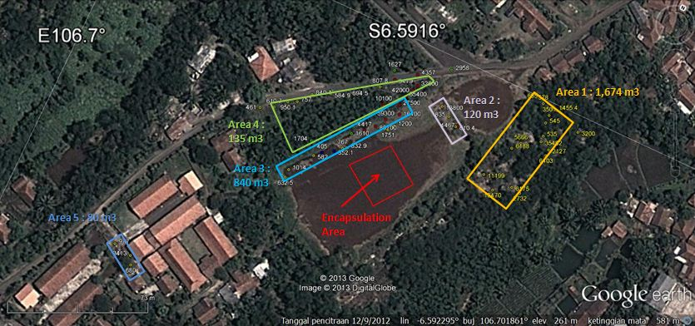
Figure 1. Extent of Soil Contamination
The completed project location includes a football field and the adjacent area that has become contaminated with lead waste from recycling operations. The main Cinangka Primary School (1,015 students) is located 100 meters from the football field (lat. -6.592774, long. - 106.701236). The final Project Area includes the football pitch and the surrounding terraced soils to the east, northeast and northwest of the location, where waste materials were dumped in an effort to level the playing field. Battery casings, plastic dividers and piles of lead oxide slag were exposed within these soils. The location is terraced, with the field dropping off 2-5 meters to the east.

Solution Implemented

Blacksmith Institute and KPBB contracted PT Karya Kencana to provide heavy equipment and labor for the construction of the encapsulation. Blacksmith Technical Advisors provided design consulting, field training and onsite field management to the construction crews. Communication with stakeholders—such as the local government of Bogor Regency (BLH, Sekda, BKPRD, Dinas Tata Ruang, Dispora), the local community, and laborers—was integral to project preparation. Blacksmith and KPBB secured the necessary ermitting and political support from national and local offices of the Ministry of Environment, Ministry of Health and local government. Community education and awareness activities were conducted throughout the duration of the project from assessment and preparation through the closing of the encapsulation. All surrounding areas with identified lead waste concentrations greater than 400 ppm were field checked with the portable XRF meter by Blacksmith staff. Excavation of the area for encapsulation and isolation space for Site excavation occurred from September 2013 through March 2014. The total excavated volume is approximately 7200 cubic meters, for 2850 cubic meters of waste and 4750 cubic meters of combined liner, limestone and clean cover.
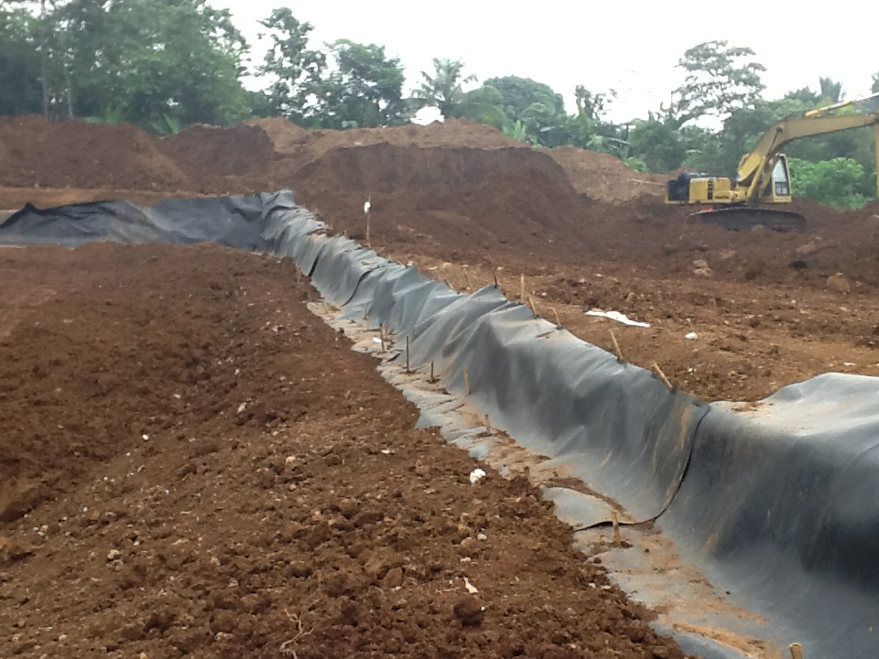
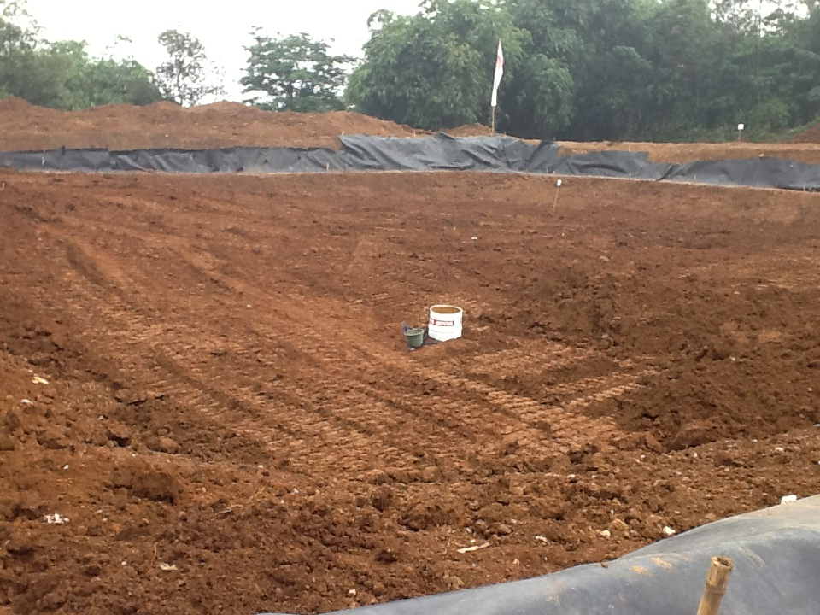

Project Performance

Preconstruction activities in September 2013 included local government meetings, worker training for protection against lead hazards, adult community meetings with project summary information, and school presentations on lead hazards. The contractor built fencing, removed vegetation, and excavation began on September 30th, 2013. The encapsulation was double-lined, with 0.5 m thickness of clay, and a 1.4 mm thick HDPE geo-membrane placed on the bottom, sides and top. A 0.3 m thick layer of crushed limestone rock was added to the design in the interior of the cell to regulate pH, reduce acidity in any water, and limit solubility and mobility of lead compounds from the waste. The top of the waste cell was 2 m below grade, capped with the HDPE geo-membrane and 0.5 m of clay, then 1.5 m of compacted clean fill. This thick layer of clean cap will allow installation of a future irrigation and drainage layer for a proposed mini-stadium without disturbing the waste cell.

After the installations were complete, topsoil was returned to the remediated site and flattened. The expectation is that grasses will grow atop the field, returning it to its intended function as a field for sport and recreation space. The regency of Bogor plans to build a concrete “mini-stadium” within the next 5 years.

Outcomes and Follow Up

In April 2014, Blacksmith Institute received an official letter from the Ministry of Environment declaring the site pollution-free. Due to the high levels of lead waste present in the encapsulation, a monitoring program has been put in place twice a year (wet/dry seasons).

Blacksmith and KPBB monitoring will focus on:

1. Maintaining physical integrity of encapsulation (no erosion, digging or drilling in the encapsulation area), and maintaining local government and public awareness of the risks of disturbing the encapsulation

2. Checking for potential impacts on surface water or groundwater from lead migration (define a limited water sampling program of existing wells closest to the encapsulation, especially those supplying schools and government office, and the closest surface water, the stream immediately below the encapsulation).

3. A brief monitoring report for regulatory staff will be completed after each monitoring event, and should be shared with well owners and local government to maintain local government and public awareness of the risks of disturbing the encapsulation.

In addition to these activities, Blacksmith continues:

- To work in Cinangka on the phase out of the battery smelting industry
- To support the Ministry of Envrionment with Technical Advising on additional lead-contaminated sites
- Monitoring of childhood blood lead levels
- Awareness and education about the dangers of lead

